A CRM APPLICATION FOR
THECHAISHOP&CO

A CRM APPLICATION FOR
THECHAISHOP&CO
User Story:
As a sales representative at TheChaiShop&Co, I want to efficiently manage customer
relationships and streamline sales processes using our CRM application.
I want to easily access and update employer details, as well as distinguish between online
and offline customer records using record types, allowing for personalized interactions.
Additionally, I need the application to automate sales calculations, such as order quantity
and total bill amount, to ensure accurate and efficient transactions.
Moreover, I require the ability to generate insightful reports and dashboards to summarize
and analyze sales data effectively, aiding in decision-making and strategy development.
Lastly, I would like the application to automate email notifications to customers on their
birthdays, informing them of special offers tailored to celebrate their special day,
enhancing customer engagement and loyalty.

1. INTRODUCTION
1.1 Project Overview :
The project “A CRM Application for TheChaiShop&Co” focuses on developing a
Salesforce-based Customer Relationship Management (CRM) system to manage
customer, employer, and enterprise accounts efficiently. The system automates sales
processes, maintains customer records, generates reports, and improves customer
engagement through automated notifications.
The project user story and objectives are defined in the initial section of the document

1.2 Purpose :
The purpose of this project is to:
● Streamline customer relationship management
● Automate billing and order calculations
● Improve data accuracy
● Enable data-driven decision-making
● Enhance customer engagement through email automation

2. IDEATION PHASE
2. P1 roblem Statement (Customer Problem Statement Template) 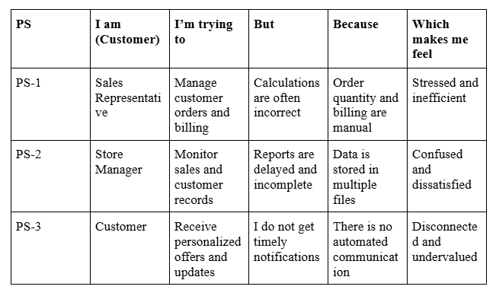

PS I am I’m trying But Because Which
(Customer) to makes me
feel
PS-1 Sales Manage Calculations Order Stressed and
Representati customer are often quantity and inefficient
ve orders and incorrect billing are
billing manual
PS-2 Store Monitor Reports are Data is Confused
Manager sales and delayed and stored in and
customer incomplete multiple dissatisfied
records files
PS-3 Customer Receive I do not get There is no Disconnecte
personalized timely automated d and
offers and notifications communicat undervalued
updates ion

2.2 Empathy Map Canvas
Target Users
● Sales Representatives
● Managers
● System Administrators
● Business Analysts
Empathy Analysis
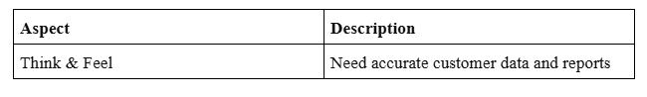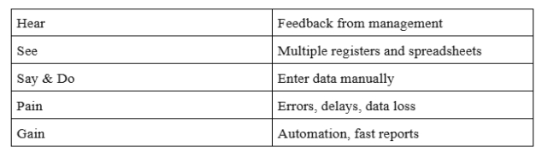
Aspect Description
Think & Feel Need accurate customer data and reports
Hear Feedback from management
See Multiple registers and spreadsheets
Say & Do Enter data manually
Pain Errors, delays, data loss
Gain Automation, fast reports
2.3 Brainstorming
Brainstormed Ideas
● Manual CRM system
● Excel-based management
● Web-based CRM
Selected Idea:
Salesforce-based CRM Application for TheChaiShop&Co..

● Salesforce-based CRM
● Automated email system
Selected Idea:
Salesforce-based CRM Application for TheChaiShop&Co..
3.REQUIREMENT ANALYSIS PHASE
3.1 Customer Journey Map
Journey Stages:
● Login
● Access CRM Application
● Enter Customer Data

● Generate Orders
● Calculate Bills
● View Reports
● Decision Making
3.2 Solution Requirements

Functional Requirements
FR No Requirement
FR-1 User Login
FR-2 Object Creation
FR-3 Data Entry
FR-4 Billing Automation
FR-5 Report Generation
FR-6 Email Automation

Non-Functional Requirements
NFR-1: Usability
The system should be easy to use for sales representatives, managers, administrators, and
analysts without requiring technical training.
Requirements :
● Simple and intuitive user interface
● Clear navigation menus
● Easy-to-understand form● User-friendly dashboards
Example:
A new sales employee should be able to log in, enter customer details, and generate
orders within a few minutes without help.
Salesforce Lightning UI provides drag-and-drop features and easy navigation.
NFR-2: Security
The system must protect customer and business data from unauthorized access.
Requirements:
● Role-based access control
● Secure login authentication
● Encrypted data storage
● Data backup and recovery
Examples:
● Profiles and permission sets
● Object-level and field-level security
● Restricted billing access
● Secure login and password policies
NFR-3: Reliability
The CRM system should work correctly at all times and store data accurately without
loss.
Requirements:
● Automatic data saving
● Regular system backups
● Error handling mechanisms
● Stable cloud environment
Example :
If a user enters order data and the internet disconnects, the system should save the
information and restore it later.
Salesforce cloud ensures automatic backups.
NFR-4: Performance
The system should respond quickly and handle large amounts of data efficiently.
Requirements:
● Fast page loading
● Quick report generation
● Smooth dashboard rendering
● Minimal delay
Example: When a manager generates monthly sales reports for hundreds of customers,
the report should load within 2–3 seconds.
Optimized queries and caching improve speed.
NFR-5: Availability
The system should be accessible whenever required.
Requirements:
● 24/7 system availability
● Minimal downtime
● Cloud-based hosting
● Disaster recovery
Example: Managers should be able to access the CRM system during peak business
hours, weekends, or late nights.
Salesforce cloud provides high uptime.
NFR-6: Scalability
The system should support business growth without affecting performance.
Requirements:
● Ability to handle more users
● Support increasing customer data
● Expandable storage
● Maintain system speed
Example: If TheChaiShop&Co expands to multiple branches, the CRM system should
support thousands of customers without slowing down.
Salesforce infrastructure automatically scales.
3.3 Data Flow Diagram
User → Salesforce UI → Custom Objects → Validation Rules → Flows → Reports →
Dashboards.

3.4 Technology Stack
Layer Technology
Frontend Salesforce Lightning
Database Salesforce Cloud
Automation Flows
Backend Salesforce Platform
Analytics Reports & Dashboards

4. PROJECT DESIGN PHASE
4.1 Problem–Solution Fit
The CRM system replaces manual records with automated data management. Cloud
storage prevents data loss, dashboards improve analysis, and real-time reports eliminate
delays. This ensures accurate and timely business insights generation

4.2 Proposed Solution
Functional Requiremennt
Parameter Description
User Login & Allows authorized users to securely log in to the CRM system
Authentication using valid credentials.
Customer Record Enables users to create, view, update, and delete customer details
Management such as name, contact number, and address.
Employer & Allows management of employer and enterprise account
Enterprise information for business operations.
Management
Order Management Supports creation and tracking of customer orders, including
order quantity and product details.
Automated Billing Automatically calculates total bill amount using formula fields
System based on order quantity and pricing.
Validation Rules Ensures accurate data entry by validating fields such as phone
number, PAN, and Aadhaar.
Record Types & Provides different record types and layouts for various customer
Page Layouts and enterprise categories.
Global Picklists Maintains standardized values for fields such as product type,
category, and status.
Email Notification Sends automated emails to customers for birthdays, offers, and
System order confirmations.
Workflow & Flow Automates tasks such as updating records and triggering alerts
Automation using Salesforce Flows.
Report Generation Generates detailed reports on sales, customers, and enterprise
performance.
Dashboard Displays real-time analytics through interactive dashboards and
Visualization charts.
Data Backup & Ensures secure storage and recovery of business data in the
Recovery Salesforce cloud.
User Role Controls system access using profiles and permission sets for
Management different users.

4.3 Solution Architecture
Architecture Layers
1. Presentation Layer – Lightning UI
2. Application Layer – Flows and Logic
3. Data Layer – Custom Objects
4. Analytics Layer – Reports and Dashboards
This layered architecture ensures modularity, scalability, and maintainability.

5. PROJECT PLANNING & SCHEDULING
5.1 Project Planning
● The project followed an Agile-based development approach with defined
milestones and sprints.
● A Salesforce Developer account was created to set up the development
environment.
● Custom objects were designed to store customer, employer, and enterprise data.
● Custom tabs and a Lightning Application were developed for easy system
navigation.
● Fields, relationships, and global picklists were configured to ensure data
consistency.
● Page layouts and record types were created based on user roles and customer
categories.
● Validation rules were implemented to prevent incorrect data entry.
● Email templates and automated flows were developed for customer notifications.
● Reports and dashboards were created for performance monitoring and analysis.
● Regular sprint reviews and testing were conducted to track progress and resolve
issues.
● The project was completed within the planned timeline through systematic
scheduling.
Product Backlog, Sprint Schedule, and Estimation (4 Marks)
Use the below template to create product backlog and sprint schedule
Sprint Functional User User Story / Task Story Priority Team
Requirement Story Points Member
(Epic) Number s
Sprint-1 Developer USN-1 As an admin, I want to create a 1 High Member1
Setup Salesforce developer account so
that I can configure and deploy the
TheChaiShop&Co CRM
application.
Sprint-1 Data Modeling USN-2 As an admin, I want to create 3 High Member2
Customer, Employer, and
Enterprise objects so that business
data can be stored and managed
systematically.
Sprint-2 Data Modeling USN-3 As a user, I want separate tabs for 3 High Member3
each object so that I can easily
navigate and manage CRM
records within the application.
Sprint Functional User User Story / Task Story Priority Team
Requirement Story Points Member
(Epic) Number s
Sprint-2 Data Modeling USN-4 As a manager, I want a dedicated 3 High Member4
Lightning App so that all CRM
operations are accessible from a
single dashboard.
Sprint-2 Data Modeling USN-5 As an admin, I want to create 5 Medium Member1
customer and order fields so that
complete sales and billing details
can be captured accurately.
Sprint-2 Data Modeling USN-6 As a user, I want customized page 5 High Member2
layouts for different record types so
that only relevant information is
displayed during data entry
Sprint-2 Data Modeling USN-7 As a manager, I want separate 5 Medium Member3
record types for Retail and
Enterprise customers so that
different business categories can
be managed efficiently.
Sprint-3 Automation USN-8 As a system, I want to validate 3 High Member4
customer details and order inputs
so that incorrect data entries are
prevented.
Sprint-3 Automation USN-9 As a system, I want automated 5 High Member1
flows to send email notifications so
that customers receive timely
updates and offers.
Sprint-4 Automation USN-10 As a system, I want to 5 High Member2
automatically calculate billing
amounts so that invoices are
generated without manual effort.
Sprint-5 Reports USN-11 As a manager, I want sales and 4 High Member3
customer reports so that I can
monitor business performance and
make informed decisions.
Sprint-6 Dashboards USN-12 As a manager, I want visual 4 Medium Member4
dashboards so that I can quickly
analyze sales, customers, and
enterprise performance.

Project Tracker, Velocity & Burndown Chart: (4 Marks)
Sprint Total Story Duratio Sprint Start Sprint End Date Story Points Sprint Release
Points n Date (Planned) Completed Date (Actual)
(as onPlanned End
Date)
Sprint-1 20 6 Days 24 Oct 2022 29 Oct 2022 20 29 Oct 2022
Sprint-2 20 6 Days 31 Oct 2022 05 Nov 2022
Sprint-3 20 6 Days 07 Nov 2022 12 Nov 2022
Sprint-4 20 6 Days 14 Nov 2022 19 Nov 2022
6. Project Development Phase:
Project Flow
Milestone 1 : Creation of developer account
Milestone 2 : Object Creation
Milestone 3 : Tabs
Milestone 4 : The Lightning App
Milestone 5 : Global Picklist
Milestone 6 : Fields and Relationships
Milestone 7 : Creation of Page Layout
Milestone 8 : Creation of Record Types
Milestone 9 : Validation rules
Milestone 10 : Email Templates
Milestone 11 : Flows
Milestone 12 : Reports and Dashboards
Milestone 13 : Conclusion
What you'll learn
1. Real Time Salesforce Project

2. Standard and Custom objects
3. Picklist Value sets
4. Types of Fields & their relationships.
5. Page Layouts
6. Record Types
7. Validation Rules
8. Email Templates
9. Flows
10. Reports and Dashboards.
Implementation
Milestone 1 - Salesforce developer account creation :
Activity 1: Creating Developer Account:
Creating a developer org in salesforce.
1. Go to https://developer.salesforce.com/signup
2. On the sign up form, enter the following details :
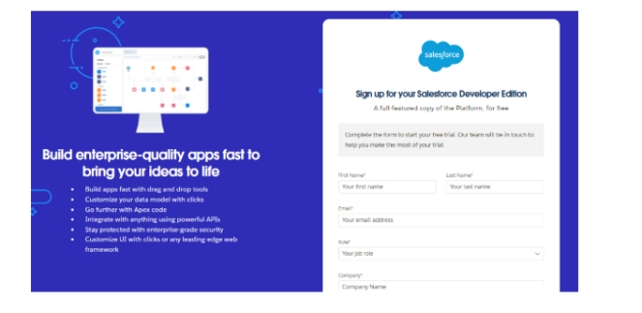
1) First name & Last name
2) Email
3) Role : Developer
4) Company : College or Company Name
5) County : India
6) Postal Code : pin code
7) Username : should be a combination of your name and company
This need not be an actual email id, you can give anything in that format :
username@organization.com
Click on sign me up after filling these.

Activity 2: Account Activation :
1. Go to the inbox of the email that you used while signing up. Click on the verify
account to activate your account. The email may take 5-10mins.
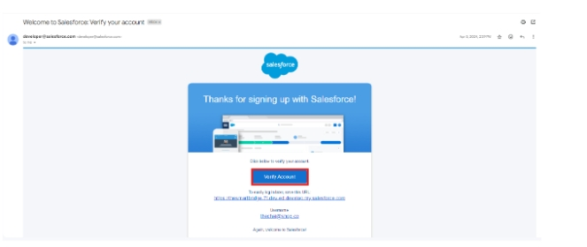
2. Click on Verify Account.
3. Give a password and answer a security question and click on change password.
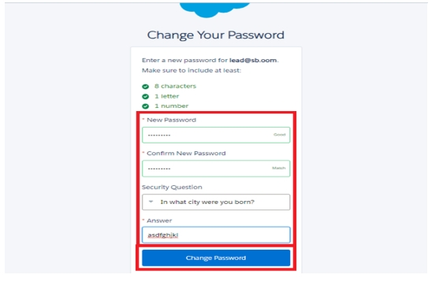
4. Then you will redirect to your salesforce setup page
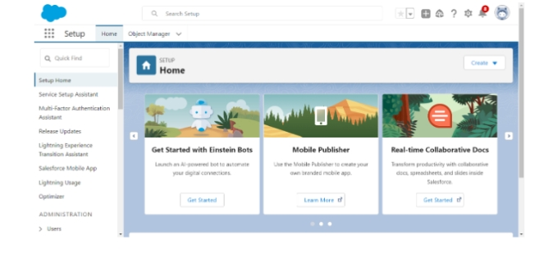
.
Milestone 2 - Objects
1. In your Salesforce org, click gear icon on the top left and select Setup to
open Setup.
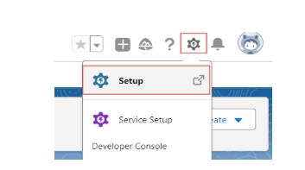

2. Click the Object Manager tab. If you don’t see it, enter Object Manager in
the Quick Find box.
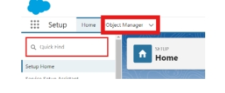
3. On the Object Manager page, click Create | Custom Object.
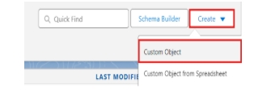
Activity 1 : Employer Account Object
1. From the setup page → Click on Object Manager → Click on Create → Click on
Custom Object.
● Label : Employer Account
● Plural Label : Employer Accounts
● Enter Record Name Label and Format
Record Name : Employer Account Name
Data Type : Text
● In Optional features : check the boxes for Allow Reports | Allow Activities
| Track Field History.
● Search Status : check the box for Allow Search.
● Save

Activity 2 : Customer Account Object
1. From the setup page → Click on Object Manager → Click on Create → Click on
Custom Object.
● Label : Customer Account
● Plural Label : Customer Accounts
● Enter Record Name Label and Format
Record Name : Customer Account Name
Data Type : Text
● In Optional features : check the boxes for Allow Reports | Allow Activities
| Track Field History.
● Search Status : check the box for Allow Search.
● Save
Activity 3 : Enterprise Account Object
1. From the setup page → Click on Object Manager → Click on Create → Click on
Custom Object.
● Label : Enterprise Account
● Plural Label : Enterprise Accounts
● Enter Record Name Label and Format
Record Name : Enterprise Account Name
Data Type : Text
● In Optional features : check the boxes for Allow Reports | Allow Activities
| Track Field History.
● Search Status : check the box for Allow Search.
● Save
Milestone 3 - Tabs
Activity 1 : Custom tabs creation
1. Go to setup page → type Tabs in Quick Find bar → click on tabs → New
(under custom object tab)
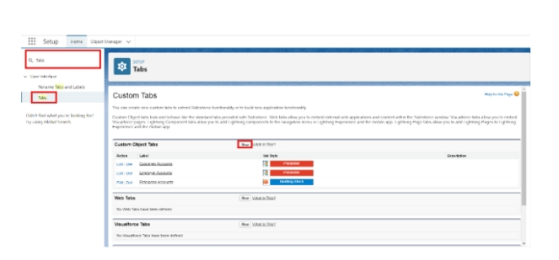
2. Select Object(Employer Accounts) → Select the tab style → Next (Add to
profiles page) keep it as default → Next (Add to Custom App) uncheck
the include tab .
3. Make sure that the Append tab to users' existing personal customizations
is checked.
4. Click save.
5. Repeat the same steps for Customer Accounts and Enterprise Accounts.

Milestone 4 - The Lightning App
Activity 1 : Create a lightning app
1. Go to setup page → search “app manager” in quick find → select “app manager”
→ click on New lightning App.
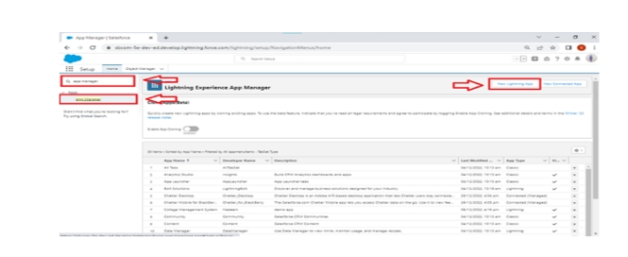

2. Fill the app name in app details and branding as follow
App Name : TheChaiShop&Co
Developer Name : Auto Populates
Add image optional (if you want to give any image you can otherwise not
mandatory) - Add Primary color Hex or leave it to default.
Then click Next.

3. In App options
Navigation style : Standard navigation
Setup experience : setup
Supporters form factors : Desktop and phone
Then click Next

4. In Utility items
Utility Bar alignment : Default
Then click Next.

5. Navigation items
Select the created Custom Objects and required standard objects
● Customer Accounts
Employer Accounts
Enterprise Accounts
Reports
Dashboards
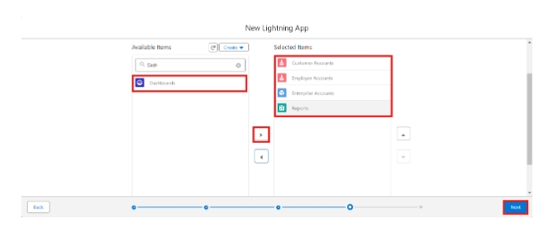
6. To Add User Profiles : System Administrator
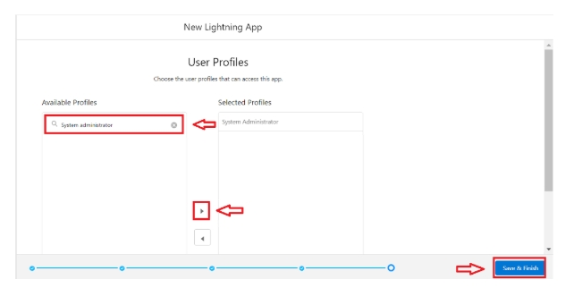
7. Click Save & Finish.
Milestone 5 : Global Picklist
Activity 1 : Create Global PIcklist
- In Quick find box search for : Picklist value sets and click New.
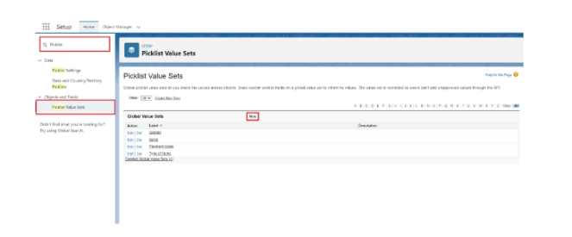● Label : Gender
Name : Auto Populates
Values : Male
Female
Others
Click Save & New.
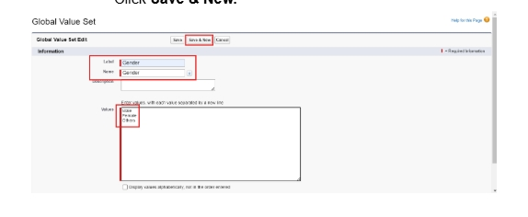
2. Create three more Global picklists following the same steps.
● Label : Items
Name : Auto populates
Values : Platinum Tea Powder
Double Delight Tea Powder
Super Dust Tea Powder
Osmania Biscuits (Value Pack)
Osmania Biscuits (Premium Pack)
Dry Fruit Biscuits
Fruit Biscuit
Salt Biscuits
Multigrain Biscuits
Ragi Biscuits
Double Choco Chip Cookies
Butter Almond Cookies
Melting Moments Cookies
Honey Oats Cookies
Delight Box
Signature Box
Assorted Box
Click Save & New.
● Label : Payment Mode
Name : Auto populates
Values : Gpay
PhonePe
Paytm
Credit or Debit card
Cash.
Click Save & New.
● Label : Type of Items
Name : Auto populates
Values : Tea powder
Cookies
Gift Hampers
Click Save.
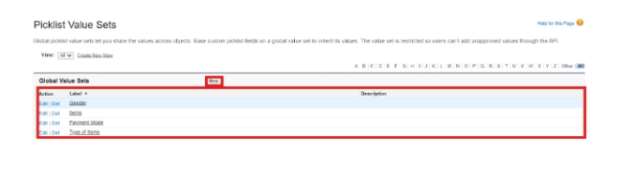

Milestone 6 : Fields & Relationships
Activity 1 : Create Custom fields for Employer Account
1. In your Salesforce org, click gear icon on the top left and select Setup to open
Setup.
2. Click the Object Manager tab. If you don’t see it, enter Object Manager in the
Quick Find box.
3. From the object manager page, In the Quick Find box, Search for the custom
object you just created : Employer Account
4. From the sidebar, click Fields & Relationships. Notice that there are already
some fields there. Those are the standard fields.
5. Click New to create a custom field. Tip: Before creating a new field, do a quick
search to make sure a similar one doesn’t already exist.

6. Next, choose a data type as Text. Choosing a data type helps you format the field
input.
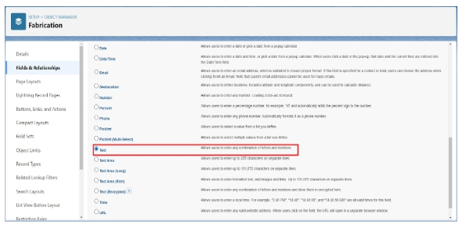
7. Click on next.
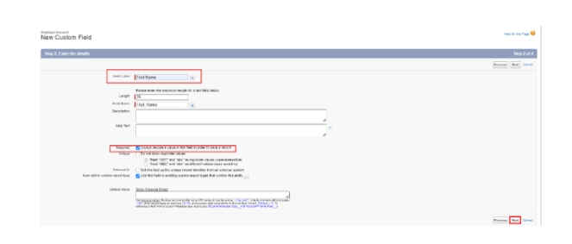
8. Data Type : Text
Field Label: First Name
Field Name : Auto Populates
Length : 25
Required : Check the box
Click on Next → Next → Save and new.
9. Repeat the Same steps for remaining fields
● Data Type : Text
Field Label: Last Name
Field Name : Auto Populates
Length : 25
Required : Check the box
Click on Next → Next → Save and new.
● Data Type : PickList
Field Label: Gender
Values : Use Global Picklist value set and
select Gender from the dropdown menu.
Field Name : Auto Populates.
Required : Check the box
Click on Next → Next → Save and new.
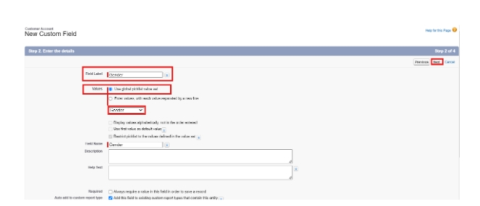
● Data Type : Phone
Field Label : Phone Number
Field Name : Auto Populates
Required : Check the box
Click on Next → Next → Save and new.
● Data Type : Email
Field Label : Email ID
Field Name : Auto Populates
Required : Check the box
Click on Next → Next → Save and new.
● Data Type : Date
Field Label : Date of Birth
Field Name : Auto Populates
Required : check the box
Click on Next → Next → Save and new.
● Data Type : Text
Field Label : Aadhar Number
Field Name : Auto Populates
Length : 12
Click on Next → Next → Save and new.
● Data Type : Text
Field Label : PAN Details
Field Name : PAN_Details
Length : 10
Click on Next → Next → Save and new.
● Data Type : Picklist
Field Label : Designation
Field Name : Auto Populates
Value : Enter value, with each value separated by a new line.
Manager
Finance and Accounting
Kitchen Staff
Cashier
Servers
Click on Next → Next → Save and new.
● Data Type : Currency
Field Label : Salary
Field Name : Auto Populates
Click on Next → Next → Save.
Activity 2: Create Custom fields for Customer Account
1. Data Type : Text
Field Label: First Name
Field Name : Auto Populates
Length : 25
Required : Check the box
Click on Next → Next → Save and new.
2. Data Type : Text
Field Label: Last Name
Field Name : Auto Populates
Length : 25
Required : Check the box
Click on Next → Next → Save and new.
3. Data Type : PickList
Field Label: Gender
Values : Use Global Picklist value set and
select Gender from the dropdown menu.
Field Name : Auto Populates.
Required : Check the box
Click on Next → Next → Save and new.
4. Data Type : Phone
Field Label : Phone Number
Field Name : Auto Populates
Required : Check the box
Click on Next → Next → Save and new.
5. Data Type : Date
Field Label : Date of Birth
Field Name : Auto Populates
Required : check the box
Click on Next → Next → Save and new.
6. Data Type : Formula
Field Label : Date of Birthday is today ?
Field Name : Auto Populates
Formula Return : Checkbox
Formula :
IF(
AND(
DAY( TODAY() ) = DAY( Date_of_Birth__c ) ,
MONTH ( TODAY()) = MONTH( Date_of_Birth__c )),
TRUE,
FALSE)
Click on Next → Next → Save and new.
7. Data Type : Email
Field Label : Email ID
Field Name : Auto Populates
Required : Check the box
Click on Next → Next → Save and new.
8. Date Type : Text
Field Label : Address
Field Name : Auto Populates
Length : 125
Click on Next → Next → Save and new.
9. Date Type : Multi Select Picklist
Field Label : Type of Items
Values : Use Global Picklist value set and
select Type of Items from the dropdown menu.
Field Name : Auto Populates.
Required : Check the box
Click on Next → Next → Save and new.

10. Date Type : Multi Select Picklist
Field Label : Products purchased
Values : Use Global Picklist value set and
select Items from the dropdown menu.
Field Name : Auto Populates.
Required : Check the box
Click on Next → Next → Save and new.

11. Date Type : Multi Select Picklist
Field Label : Chai
Value : Enter value, with each value separated by a new line.
TheChaiShop&Co Special Tea
Single Tea
Masala Tea
Lemon Tea
Ginger Tea
Green Tea
Sugar Free Tea
Click on Next → Next → Save and new.
12. Data Type : Picklist
Field Label : Payment Mode
Values : Use Global Picklist value set and
select Payment Mode from the dropdown menu.
Field Name : Auto Populates.
Required : Check the box
Click on Next → Next → Save and new.
13. Data Type : Lookup Relationship
Related To : Employer Account
Field Label : Associated Employer
Field Name : Auto Populates
Click on Next → Next → Save and new.
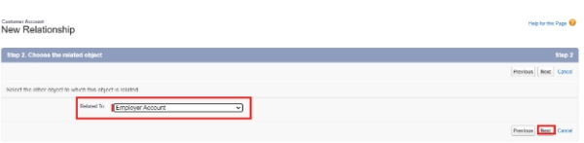
14. Data Type : Formula
Field Label : Order Quantity
Field Name : Auto Populates
Formula Return : Number
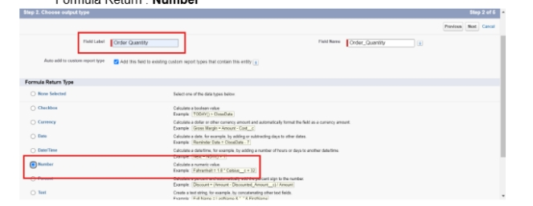
Enter Formula = Quantity (Number) =
IF(INCLUDES( Products_Purchased__c , "Platinum Tea Powder"), 1, 0 ) +
IF(INCLUDES( Products_Purchased__c , "Double Delight Tea Powder"), 1, 0 ) +
IF( INCLUDES( Products_Purchased__c , "Super Dust Tea Powder") , 1, 0) +
IF(INCLUDES( Products_Purchased__c , "Osmania Biscuits (Value Pack)"), 1, 0 ) +
IF(INCLUDES( Products_Purchased__c , "Osmania Biscuits (Premium Pack)"), 1, 0 ) +
IF( INCLUDES( Products_Purchased__c , "Dry Fruit Biscuits") , 1, 0) +
IF(INCLUDES( Products_Purchased__c , "Fruit Biscuits"), 1, 0 ) +
IF(INCLUDES( Products_Purchased__c , "Salt Biscuits"), 1, 0 ) +
IF(INCLUDES( Products_Purchased__c , "Multigrain Biscuits"), 1, 0 ) +
IF(INCLUDES( Products_Purchased__c , "Ragi Biscuits"), 1, 0 ) +
IF( INCLUDES( Products_Purchased__c ,"Double Choco chip Cookies") , 1, 0) +
IF(INCLUDES( Products_Purchased__c , "Butter Almond Cookies"), 1, 0 ) +
IF(INCLUDES( Products_Purchased__c , "Melting Moments Cookies"), 1, 0 ) +
IF( INCLUDES( Products_Purchased__c , "Honey Oats Cookies") , 1, 0) +
IF(INCLUDES( Products_Purchased__c , "Delight Box"), 1, 0 ) +
IF(INCLUDES( Products_Purchased__c , "Signature Box"), 1, 0 ) +
IF( INCLUDES( Products_Purchased__c , "Assorted Pack") , 1, 0) +
IF(INCLUDES( Chai__c , "TheChaiShop&Co Special Tea"), 1, 0) +
IF(INCLUDES( Chai__c , "Single Tea"), 1, 0) +
IF(INCLUDES( Chai__c , "Masala Tea"), 1, 0) +
IF(INCLUDES( Chai__c , "Lemon Tea"), 1, 0) +
IF(INCLUDES( Chai__c , "Ginger Tea"), 1, 0) +
IF(INCLUDES( Chai__c , "Green Tea"), 1, 0) +
IF(INCLUDES( Chai__c , "Sugar Free Tea"), 1, 0)
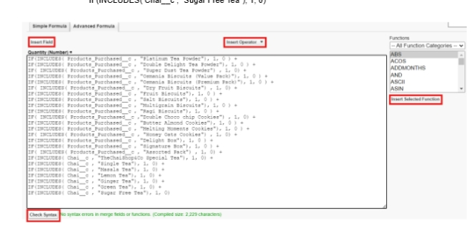
Click on Next → Next → Save and new.

15. Data Type : Formula
Field Label : Total Bill
Field Name : Auto Populates
Formula Return : Number
Enter Formula = Quantity (Number) =
IF(INCLUDES( Products_Purchased__c , "Platinum Tea Powder"), 175, 0 ) +
IF(INCLUDES( Products_Purchased__c , "Double Delight Tea Powder"), 150, 0 ) +
IF( INCLUDES( Products_Purchased__c , "Super Dust Tea Powder") , 125, 0) +
IF(INCLUDES( Products_Purchased__c , "Osmania Biscuits (Value Pack)"), 50, 0 ) +
IF(INCLUDES( Products_Purchased__c , "Osmania Biscuits (Premium Pack)"), 80, 0 ) +
IF( INCLUDES( Products_Purchased__c , "Dry Fruit Biscuits") , 110, 0) +
IF(INCLUDES( Products_Purchased__c , "Fruit Biscuits"), 160, 0 ) +
IF(INCLUDES( Products_Purchased__c , "Salt Biscuits"), 110, 0 ) +
IF(INCLUDES( Products_Purchased__c , "Multigrain Biscuits"), 170, 0 ) +
IF(INCLUDES( Products_Purchased__c , "Ragi Biscuits"), 190, 0 ) +
IF( INCLUDES( Products_Purchased__c ,"Double Choco chip Cookies") , 200, 0) +
IF(INCLUDES( Products_Purchased__c , "Butter Almond Cookies"), 110, 0 ) +
IF(INCLUDES( Products_Purchased__c , "Melting Moments Cookies"), 150, 0 ) +
IF( INCLUDES( Products_Purchased__c , "Honey Oats Cookies") , 160, 0) +
IF(INCLUDES( Products_Purchased__c , "Delight Box"), 850, 0 ) +
IF(INCLUDES( Products_Purchased__c , "Signature Box"), 1500, 0 ) +
IF( INCLUDES( Products_Purchased__c , "Assorted Pack") , 600, 0) +
IF(INCLUDES( Chai__c , "TheChaiShop&Co Special Tea"), 70, 0) +
IF(INCLUDES( Chai__c , "Single Tea"), 50, 0) +
IF(INCLUDES( Chai__c , "Masala Tea"), 60, 0) +
IF(INCLUDES( Chai__c , "Lemon Tea"), 40, 0) +
IF(INCLUDES( Chai__c , "Ginger Tea"),55, 0) +
IF(INCLUDES( Chai__c , "Green Tea"), 45, 0) +
IF(INCLUDES( Chai__c , "Sugar Free Tea"), 55, 0)
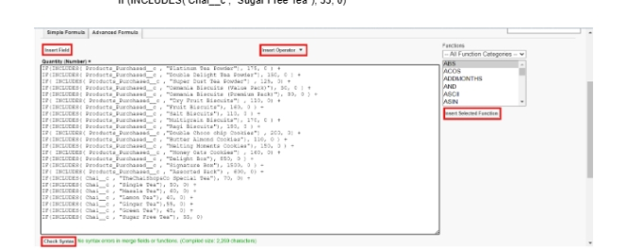
Click on Next → Next → Save.

Activity 3: Create Custom fields for Enterprise Account
1. Data Type : Text
Field Label: Enterprise Name
Field Name : Auto Populates
Length : 25
Required : Check the box
Click on Next → Next → Save and new.

2. Data Type : Phone
Field Label : Phone Number
Field Name : Auto Populates
Required : Check the box
Click on Next → Next → Save and new.
3. Data Type : Email
Field Label : Email ID
Field Name : Auto Populates
Required : Check the box
Click on Next → Next → Save and new.
4. Date Type : Text
Field Label : Address
Field Name : Auto Populates
Length : 125
Click on Next → Next → Save and new.
5. Date Type : Multi Select Picklist
Field Label : Type of Items
Values : Use Global Picklist value set and
select Type of Items from the dropdown menu.
Field Name : Auto Populates.
Required : Check the box
Click on Next → Next → Save and new.
6. Date Type : Multi Select Picklist
Field Label : Products purchased
Values : Use Global Picklist value set and
select Items from the dropdown menu.
Field Name : Auto Populates.
Required : Check the box
Click on Next → Next → Save and new.
7. Data Type : Lookup Relationship
Related To : Employer Account
Field Label : Associated Employer
Field Name : Auto Populates
Click on Next → Next → Save and new.
8. Data Type : Formula
Field Label : Order Quantity
Field Name : Auto Populates
Formula Return : Number
Enter Formula = Quantity (Number) =
IF(INCLUDES( Products_Purchased__c , "Platinum Tea Powder"), 1, 0 ) +
IF(INCLUDES( Products_Purchased__c , "Double Delight Tea Powder"), 1, 0 ) +
IF( INCLUDES( Products_Purchased__c , "Super Dust Tea Powder") , 1, 0) +
IF(INCLUDES( Products_Purchased__c , "Osmania Biscuits (Value Pack)"), 1, 0 ) +
IF(INCLUDES( Products_Purchased__c , "Osmania Biscuits (Premium Pack)"), 1, 0 ) +
IF( INCLUDES( Products_Purchased__c , "Dry Fruit Biscuits") , 1, 0) +
IF(INCLUDES( Products_Purchased__c , "Fruit Biscuits"), 1, 0 ) +
IF(INCLUDES( Products_Purchased__c , "Salt Biscuits"), 1, 0 ) +
IF(INCLUDES( Products_Purchased__c , "Multigrain Biscuits"), 1, 0 ) +
IF(INCLUDES( Products_Purchased__c , "Ragi Biscuits"), 1, 0 ) +
IF( INCLUDES( Products_Purchased__c ,"Double Choco chip Cookies") , 1, 0) +
IF(INCLUDES( Products_Purchased__c , "Butter Almond Cookies"), 1, 0 ) +
IF(INCLUDES( Products_Purchased__c , "Melting Moments Cookies"), 1, 0 ) +
IF( INCLUDES( Products_Purchased__c , "Honey Oats Cookies") , 1, 0) +
IF(INCLUDES( Products_Purchased__c , "Delight Box"), 1, 0 ) +
IF(INCLUDES( Products_Purchased__c , "Signature Box"), 1, 0 ) +
IF( INCLUDES( Products_Purchased__c , "Assorted Pack") , 1, 0)
Click on Next → Next → Save and new.
9. Data Type : Formula
Field Label : Total Bill
Field Name : Auto Populates
Formula Return : Number
Enter Formula = Quantity (Number) =
IF(INCLUDES( Products_Purchased__c , "Platinum Tea Powder"), 175, 0 ) +
IF(INCLUDES( Products_Purchased__c , "Double Delight Tea Powder"), 150, 0 ) +
IF( INCLUDES( Products_Purchased__c , "Super Dust Tea Powder") , 125, 0) +
IF(INCLUDES( Products_Purchased__c , "Osmania Biscuits (Value Pack)"), 50, 0 ) +
IF(INCLUDES( Products_Purchased__c , "Osmania Biscuits (Premium Pack)"), 80, 0 ) +
IF( INCLUDES( Products_Purchased__c , "Dry Fruit Biscuits") , 110, 0) +
IF(INCLUDES( Products_Purchased__c , "Fruit Biscuits"), 160, 0 ) +
IF(INCLUDES( Products_Purchased__c , "Salt Biscuits"), 110, 0 ) +
IF(INCLUDES( Products_Purchased__c , "Multigrain Biscuits"), 170, 0 ) +
IF(INCLUDES( Products_Purchased__c , "Ragi Biscuits"), 190, 0 ) +
IF( INCLUDES( Products_Purchased__c ,"Double Choco chip Cookies") , 200, 0) +
IF(INCLUDES( Products_Purchased__c , "Butter Almond Cookies"), 110, 0 ) +
IF(INCLUDES( Products_Purchased__c , "Melting Moments Cookies"), 150, 0 ) +
IF( INCLUDES( Products_Purchased__c , "Honey Oats Cookies") , 160, 0) +
IF(INCLUDES( Products_Purchased__c , "Delight Box"), 850, 0 ) +
IF(INCLUDES( Products_Purchased__c , "Signature Box"), 1500, 0 ) +
IF( INCLUDES( Products_Purchased__c , "Assorted Pack") , 600, 0)

10. Data Type : Picklist
Field Label : Payment Mode
Values : Use Global Picklist value set and
select Payment Mode from the dropdown menu.
Field Name : Auto Populates.
Required : Check the box
Click on Next → Next → Save.

Milestone 7 : Page Layouts
For the personalized field view in Customer Accounts, let's create two page layouts
Online orders and Walk-In orders.
Activity 1: Online Orders page layout
1. Go to the setup page → click on object manager → From drop down click edit for
Customer Account object.
- Click on the Page Layouts → click New.
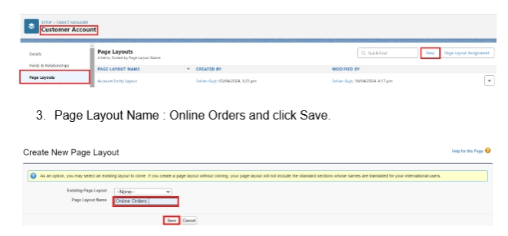
- Page Layout Name : Online Orders and click Save.
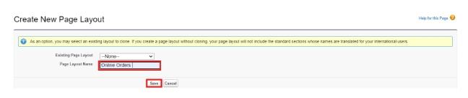
- Drag and Arrange all the required fields as shown below.
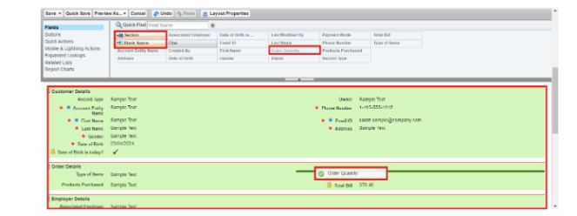
5. Click Save.
Activity 2: Walk-In Orders page layout
1. Go to the setup page → click on object manager → From drop down click edit for
Customer Account object.
2. Click on the Page Layouts → click New.
3. Page Layout Name : Walk-In orders and click save.
4. Drag and Arrange all the required fields as shown below.
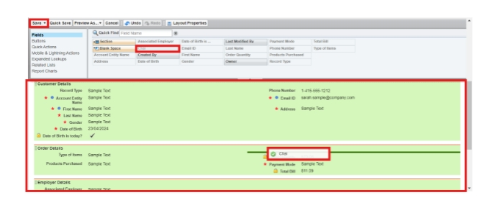
5. Click Save
.
Milestone 8 - Record Types
To Differentiate the records and data stored in Customer Accounts, let's create two
different Record Types.
Online orders and Walk-In orders.

Activity 1: Online Orders Record Type
1. Go to the setup page → click on object manager → From drop down click edit for
Customer Account object.
2. Click on the Record Types → click New.
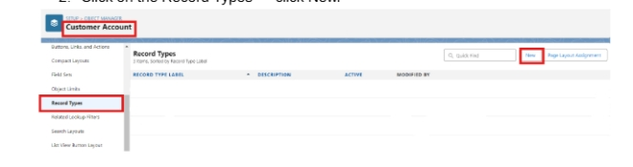
3. Enter Details :
Existing Record Type : Master
Record Type Label : Online Order
Record Type Name : Auto Populates
Active : Tick the checkbox
Click Next
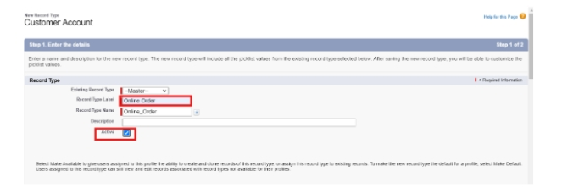
4. In Assign Page Layouts
● Select Apply one layout to all profiles : select Online orders from the drop
down menu.
5. Click Save and New.

Activity 2: Walk-In Orders Record Type
1. Go to the setup page → click on object manager → From drop down click edit for
Customer Account object.
2. Click on the Record Types → click New.

3. Enter Details :
Existing Record Type : Master
Record Type Label : Walk-In Order
Record Type Name : Auto Populates
Active : Tick the checkbox
Click Next
4. In Assign Page Layouts
● Select Apply one layout to all profiles : select Walk-In orders from the
drop down menu.
5. Click Save.

Milestone 9 - Validation Rules
Activity 1: On Employer Account
1. Go to the setup page → click on object manager → From drop down click edit for
Employer Account object.
2. Click on the validation rule → click New.
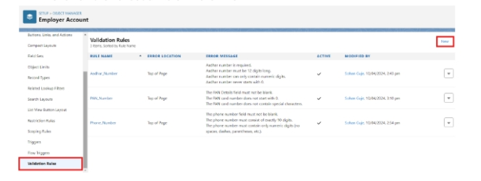
3. Enter Rule Name : Aadhar Number
Error Condition Formula :
AND(
NOT(ISBLANK( Aadhar_Number__c )),
LEN( Aadhar_Number__c ) <> 12,
NOT(REGEX( Aadhar_Number__c , "^[1-9]{12}$"))
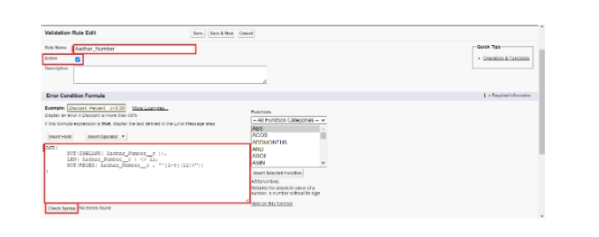
4. Error Message : Aadhar number is required.
The Aadhar number must be 12 digits long.
Aadhar number can only contain numeric digits.
Aadhar number never starts with 0
- Click Save & New.
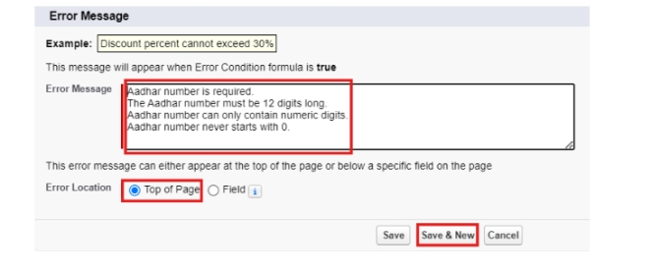
6. Repeat the same steps and create two more validation rules on the employer
account object.
● Enter Rule Name : PAN Number
Error Condition Formula :
AND(
NOT(ISBLANK( Phone_Number__c )),
NOT(REGEX( Phone_Number__c , "^[1-9]{10}$")),
NOT(REGEX( Phone_Number__c , "^\\d+$"))
)
Error Message : The PAN Details field must not be blank.
The PAN card number does not start with 0.
The PAN card number does not contain special characters.
Click Save & New.
● Enter Rule Name : Phone Number
Error Condition Formula :
AND(
NOT(ISBLANK( Phone_Number__c )),
NOT(REGEX( Phone_Number__c , "^[1-9]{10}$")),
NOT(REGEX( Phone_Number__c , "^\\d+$"))
)
Error Message :
The phone number field must not be blank.
The phone number must consist of exactly 10 digits.
The phone number must contain only numeric digits
(no spaces, dashes, parentheses, etc.)
Click Save.
Activity 2: On Customer Account
1. Go to the setup page → click on object manager → From drop down click edit for
Customer Account object.
2. Click on the validation rule → click New.
3. Enter Rule Name : Phone Number
Error Condition Formula :
AND(
NOT(ISBLANK( Phone_Number__c )),
NOT(REGEX( Phone_Number__c , "^[1-9]{10}$")),
NOT(REGEX( Phone_Number__c , "^\\d+$"))
)
Error Message :
The phone number field must not be blank.
The phone number must consist of exactly 10 digits.
The phone number must contain only numeric digits
(no spaces, dashes, parentheses, etc.)
4. Click Save.

Activity 3: On Enterprise Account
1. Go to the setup page → click on object manager → From drop down click edit for
Customer Account object.
2. Click on the validation rule → click New.
3. Enter Rule Name : Phone Number
Error Condition Formula :
AND(
NOT(ISBLANK( Phone_Number__c )),
NOT(REGEX( Phone_Number__c , "^[1-9]{10}$")),
NOT(REGEX( Phone_Number__c , "^\\d+$"))
)
Error Message :
The phone number field must not be blank.
The phone number must consist of exactly 10 digits.
The phone number must contain only numeric digits
(no spaces, dashes, parentheses, etc.)
4. Click Save.
Milestone 10 - Email Template
Activity 1: Email Template
1. Go to setup, In quick find box enter Email template → click on classic Email
Template.
2. Click on→ New Email Template
3. Choose the type of email template you would like to create : Text and click Next.
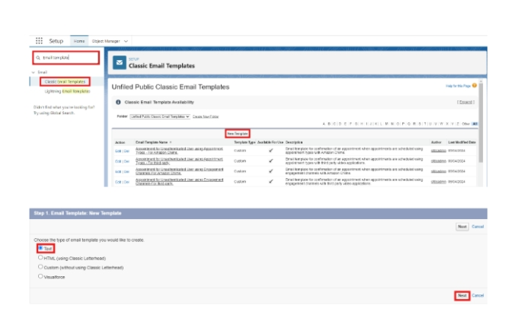
● Available Merge Fields
Select Field Type : Customer Accounts Fields
Select Field : First Name
Copy Merge Field value : Auto Populates, Copy the value and paste it in
the email body where required.
4. Folder : Unfiled public Classic Email templates
5. Click on available for use
6. Email Template Name is “Birthday Offer Email”
7. Template Unique Name : Auto populated
8. Subject : Special Birthday Offer Inside!
9. Email body :
Dear {!Customer_Account__c.First_Name__c},
Happy Birthday from all of us at TheChaiShop&Co! 🎉🎂 We hope your special day is filled with joy,
laughter, and wonderful memories.
To celebrate your birthday, we have a special gift just for you! As a token of our appreciation for your
continued support, we're delighted to offer you an exclusive birthday discount.
🎁 Birthday Offer: Enjoy a fantastic 50% off on your next purchase as our birthday gift to you!
This offer is our way of saying thank you for being a valued customer. Simply use the code
[HBDAY50] at checkout to redeem your birthday treat.
We hope this special offer adds a little extra sparkle to your birthday celebrations!
Once again, happy birthday! Thank you for choosing TheChaiShop&Co! and being part of our
community.
Warm regards
TheChaiShop&Co!
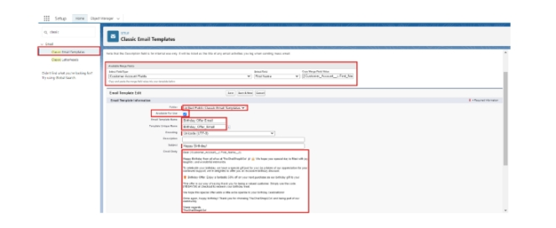
10. Click Save.
Activity 2: Email Alert
- Go to setup, In quick find box enter Email Alert → click on Email Alert .
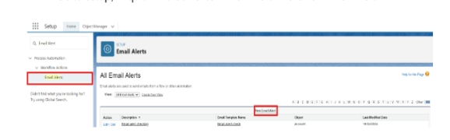
2. Click on New Email Alert.
3. Description : Happy Birthday email alert
Unique Name : Auto Populates
Object : Customer Account
Email Template : Search for Birthday Offer Email
Recipient Type : Search : Email field : Email ID
From Email Address : Default Workflow user’s email address
Click Save.
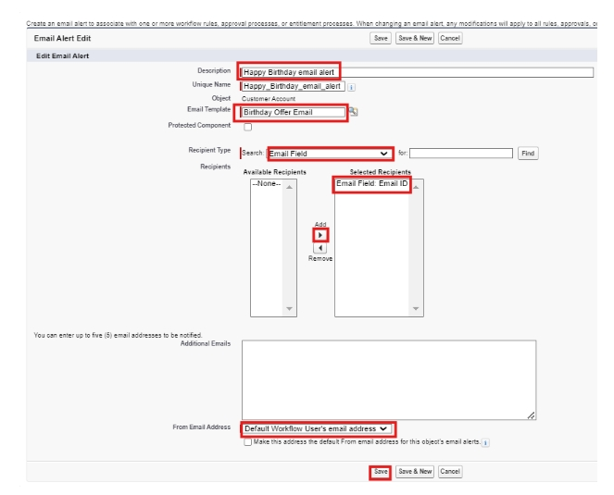
NOTE :
- Make sure that the Default workflow user is assigned.
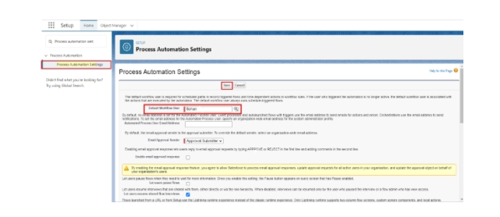

Milestone 11 - Flows
Let’s create a scheduled Triggered flow to automate the Birthday offer mails.
Activity 1: Schedule Triggered Flow
1. Go to setup, Type Flow in quick find box → Click on the Flow and Select the
New Flow.
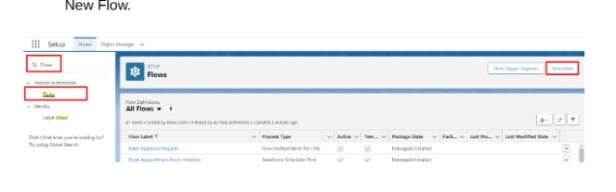
2.Select Schedule - Triggered Flow and click Create.
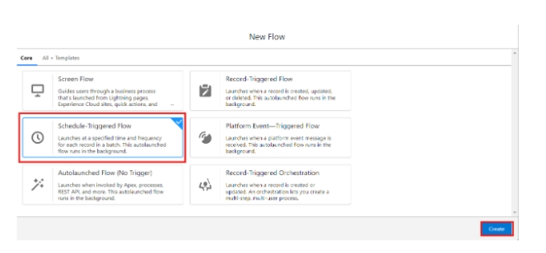
3. Set a Schedule
Start Date : Enter the Date, when you want to start the flow.
Start Time : Enter the Time, when you want to start the flow.
Frequency : Daily
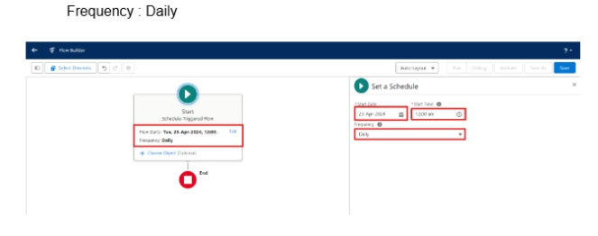
4. Create Object
Object : Customer Account
Condition Requirements : All conditions Are Met (AND)
● Field : Date_of_Birthday_is_today__c
Operator : Equals
Value : $GlobalConstant.True
● Field : Email_ID_c
Operator : IS NULL
Value : $GlobalConstant.False
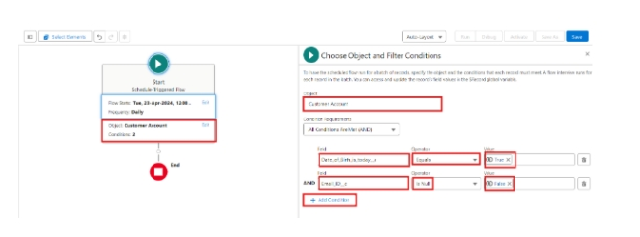
5.Click (+) Icon on the flow builder and Select Action Component.
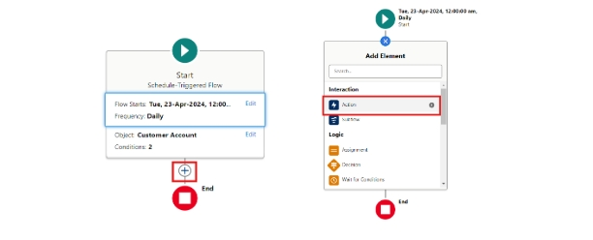
6. In New Action Page
Filter By : Type and select Email Alert
In Action : Search and select Happy Birthday email alert
Label : Send Happy Birthday Email
API Name : Auto Populates
Set Input Values for the Selected Action : Record ID : {!$Record.Id}
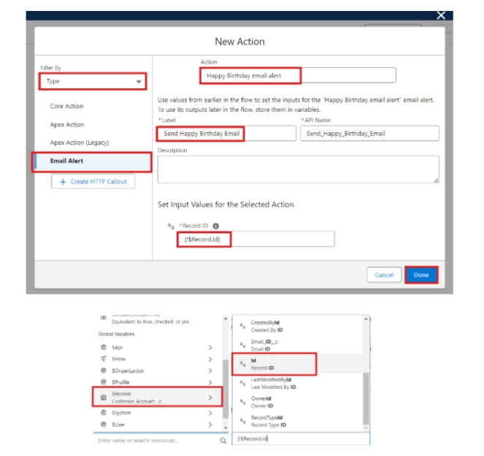
7. Click Done.
8. Click Save on the top right
Flow Label : Happy Birthday Email Flow
Flow API Name : Auto Populates
Click Save.
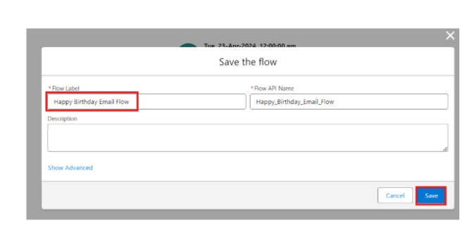
9. Click Activate.
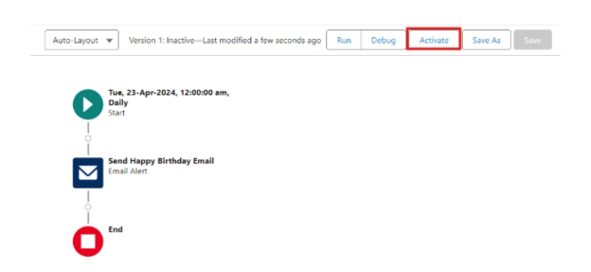
Milestone 12 - Reports & Dashboards
Activity 1: Customer Account Sales Report
1. Click App Launcher and select TheChaiShop&Co.
2. Click Reports
3. Click New Report
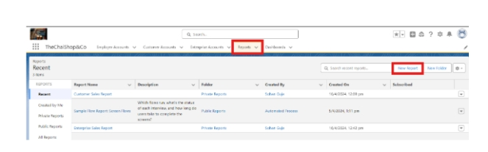
4. In search type Customer Accounts and Select Customer Accounts.
5. Click Start Report.
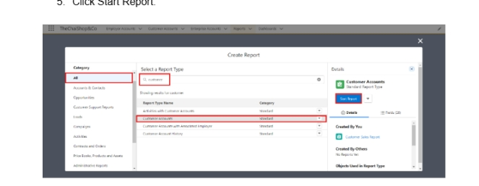
6. Click the toggle Update Preview Automatically to ON.
7. Drag and Drop all the required Columns from the Outline pane.
8. Group Rows : Search and Select
Customer Account: Record Type
9. Click Add Chart on the top.
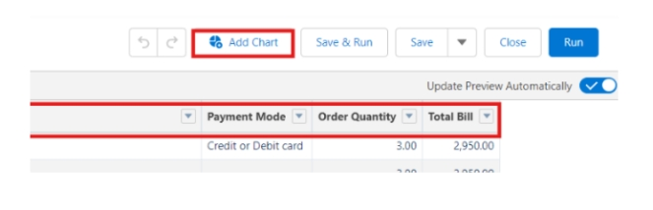
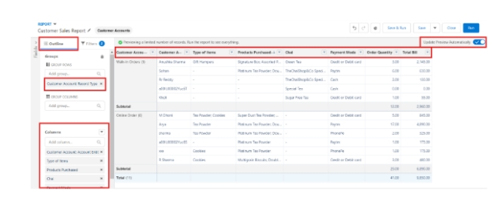
10. Click Save on the top right.
Enter
Report Name: Customer Account Sales Report
Report Unique Name : Auto Populates
Click Save.
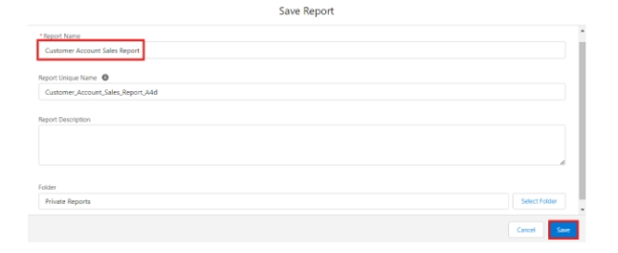

Activity 2: Enterprise Account Sales Report
1. Repeat the same steps to create another report.
2. Click Reports
3. Click New Report
4. In search type Enterprise Accounts and Select Enterprise Accounts.
5. Click Start Report.
6. Click the toggle Update Preview Automatically to ON.
Drag and Drop all the required Columns from the Outline pane.
Group Rows : Search and Select
Type of Items.
7.Click Add Chart on the top.
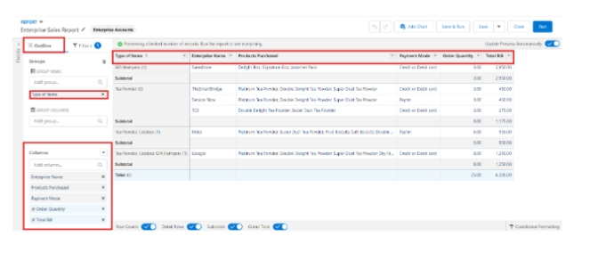

8. Click Save on the top right.
a. Enter
b. Report Name : Enterprise Account Sales Report
c. Report Unique Name : Auto Populates
d. Click Save.
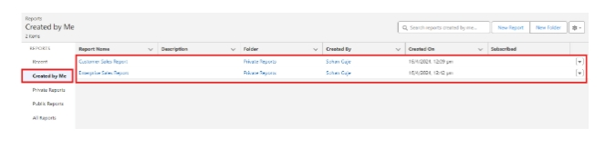

Activity 3: Dashboard
1. Click Dashboards
2. Click New Dashboards
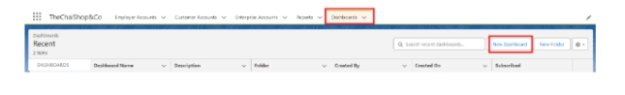
3. Name : Customer Vs Enterprise Sales
4. Click Create.
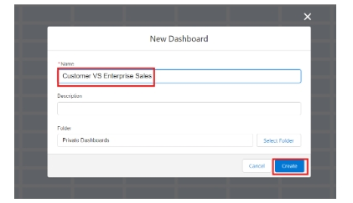
5. Click Widget
6. Select Chart or Table.
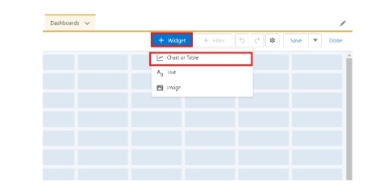
7.Select Customer Account Sales Report
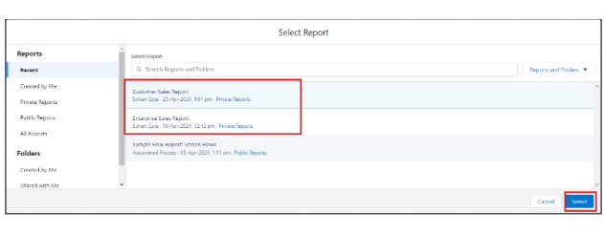
8. Display As : Select the one which you feel comfortable with.
9. Click Add.
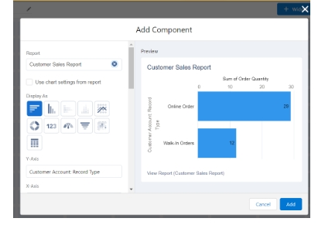

10. Repeat the same steps for the Enterprise Account Sales Report.
11. Click Save.
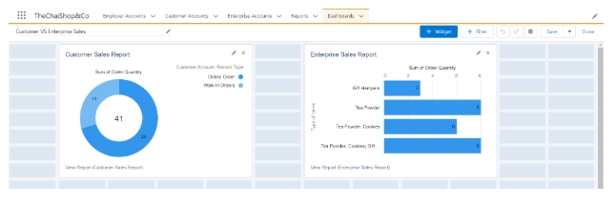
Milestone 12 - Conclusion
In conclusion, the development of TheChaiShop&Co CRM application marks a
significant stride in enhancing the store's operational efficiency and customer
relationship management capabilities. Seamlessly integrating employer details,
customer information (both online and offline), and enterprise data, this application
streamlines business processes and enables informed decision-making. The
automation of sales calculations, including order quantity and total bill amount, reduces
errors and empowers employees to focus on delivering exceptional service. Moreover,
automated email notifications for customers' birthdays foster personalized
communication and enhance customer engagement.
7. FUNCTIONAL & PERFORMANCE TESTING
During the testing phase, screenshots were captured from the Salesforce Lightning
interface to verify correct system behavior. These include:
● Record creation for Employer, Customer, and Enterprise objects
● Validation rule testing for Aadhar, PAN, and phone numbers
● Verification of record types and page layouts
● Formula field validation for order quantity and billing
● Flow execution for birthday email alerts
● Report and dashboard generation
Performance testing ensured fast response time and system stability during concurrent
usage.
8. ADVANTAGES & DISADVANTAGES
Advantages
● Centralized data management
● Reduced manual work
● Automated calculations
● Improved customer engagement
● Real-time analytics
Disadvantages
● Requires Salesforce license
● Internet dependency
● Limited offline access
9. Conclusion:
The CRM Application for TheChaiShop&Co successfully improves business operations
by integrating customer data, automating billing, and enabling intelligent reporting. The
system reduces errors, saves time, and enhances customer relationships through
automation and analytics.

10. FUTURE SCOPE
● Mobile CRM integration
● AI-based sales prediction
● WhatsApp/SMS alerts
● Inventory management
● Multi-branch support
● Advanced customer profiling

11. APPENDIX
Source Code : Salesforce Configuration & Flows
Dataset : Customer and Sales Records
Tools Used : Salesforce Developer Org
Thank You

